**Desi Bazaar Project Report**

**UML Diagram**

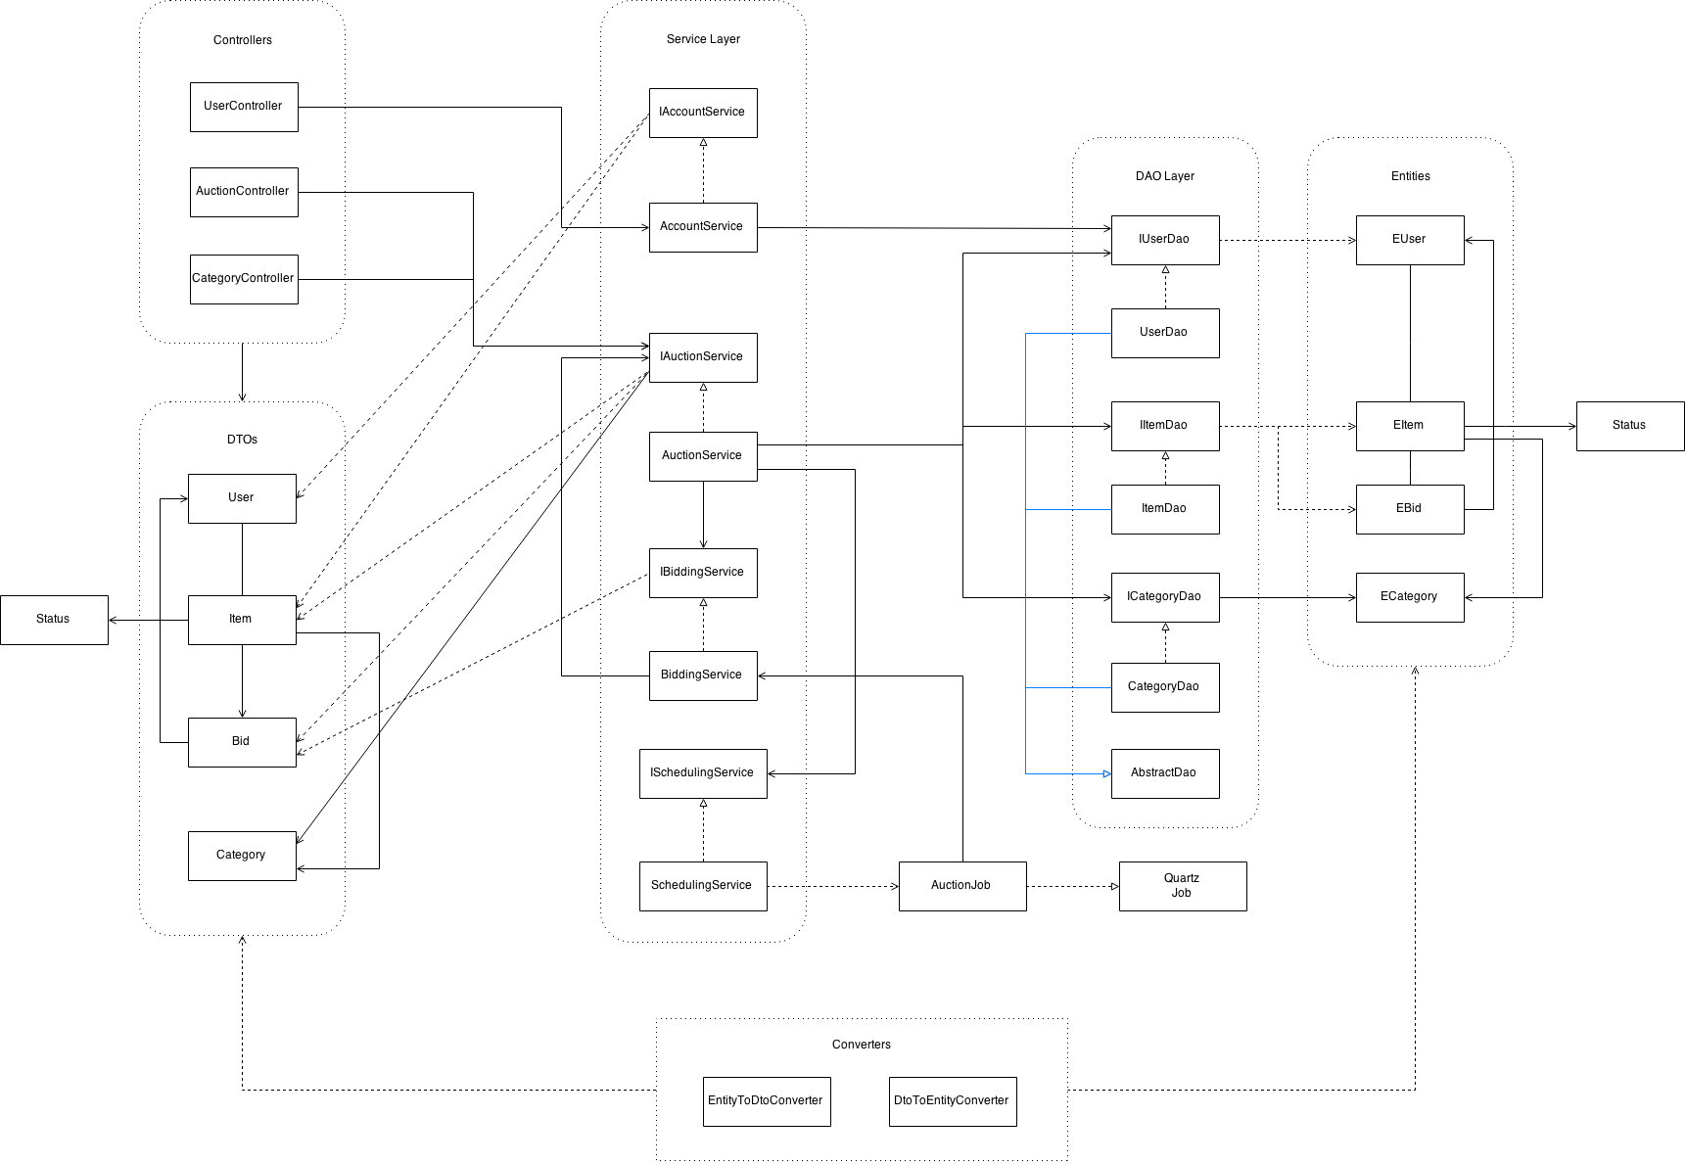

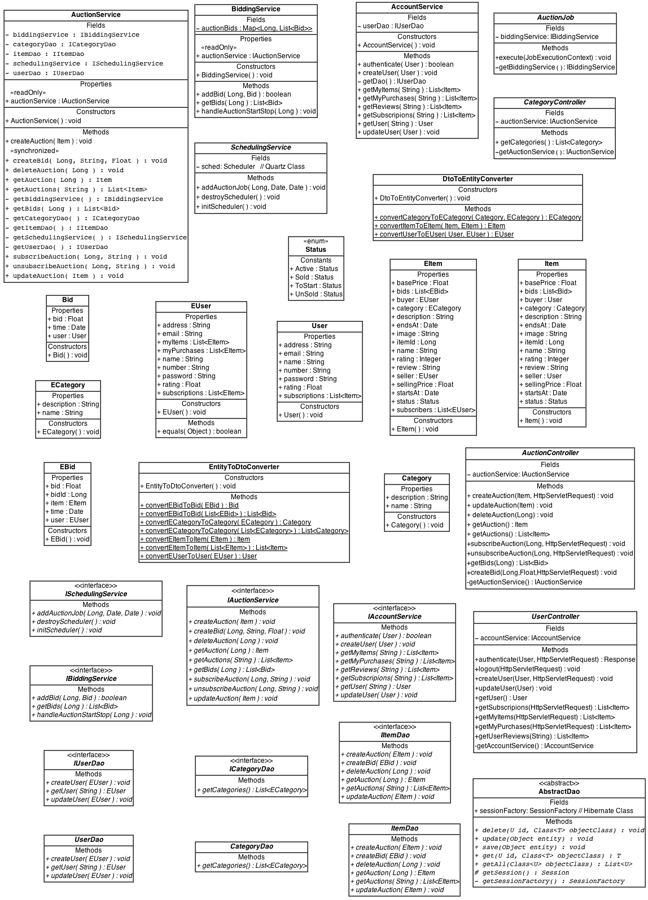

**ERD**



**INSTALLATION INSTRUCTIONS**

The following software need to installed to run the project:

1. Eclipse IDE for Java EE Developers (Luna)
2. MySQL
3. Github
4. Apache Tomcat 7

**Git Clone Procedure**

In git Terminal, use the following command to clone the repository.

“git clone https://github.com/vardalaud/desibazaar.git”

**Maven Installation Instructions**

For installing Maven on your machine, go to downloads page on apache maven website and download the latest stable version of maven. Link-

<https://maven.apache.org/download.cgi>

**Maven Plugin for Eclipse**

For working on maven in eclipse, we need the following plugins.

* Maven Integration for Eclipse (Luna) 1.5.0
* Maven (Java EE) Integration for Eclipse WTP (Luna) 1.1.0

These will be already installed if you have the eclipse version that we have mentioned. In case they are not, following these steps can download them:

1. Start Eclipse and go to Help🡪 Eclipse Marketplace and search for “maven”.
2. Install the above mentioned plugins.
3. After installing the plugins, import the project in eclipse.

**Import project procedure**

1. In the package explorer, right click and choose import.
2. Select maven and then Existing Maven Projects.

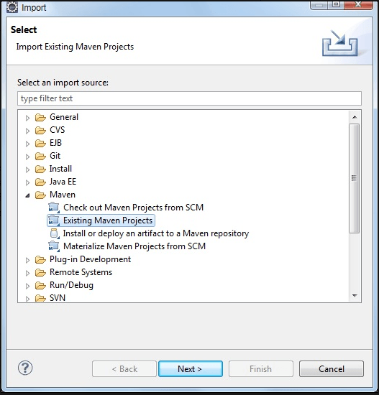

1. Give the path of the project folder here. The project would be present on the machine after cloning.

**Changing Database Properties**

1. Before running the project, change the database properties of the project by going to the following path-
2. desibazaar-rest🡪 src/main/resources🡪 databse.properties.
3. In this file, do the following

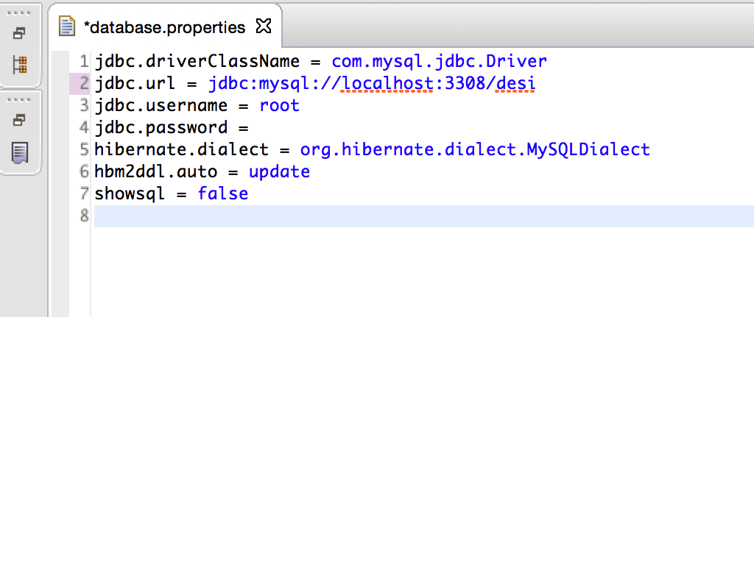

* On Line 2: **Change** “localhost:3308/desi” to

“localhost: [mysql_port_number]/[database_name]

* On line 3 and 4, enter mysql username and password respectively.
* On line 6, change “update” to “create” while running the project for the first time. This will create the database at the back end. After that, change it back to “update” so that changes could be made to the database.

**Deploying the project**

For deploying the project on server, we need to deploy the rest and web projects separately. For deploying the rest project:

* Right click on desibazaar-rest in package explorer.
* When a drop down appears, click Run as🡪 Run on Server

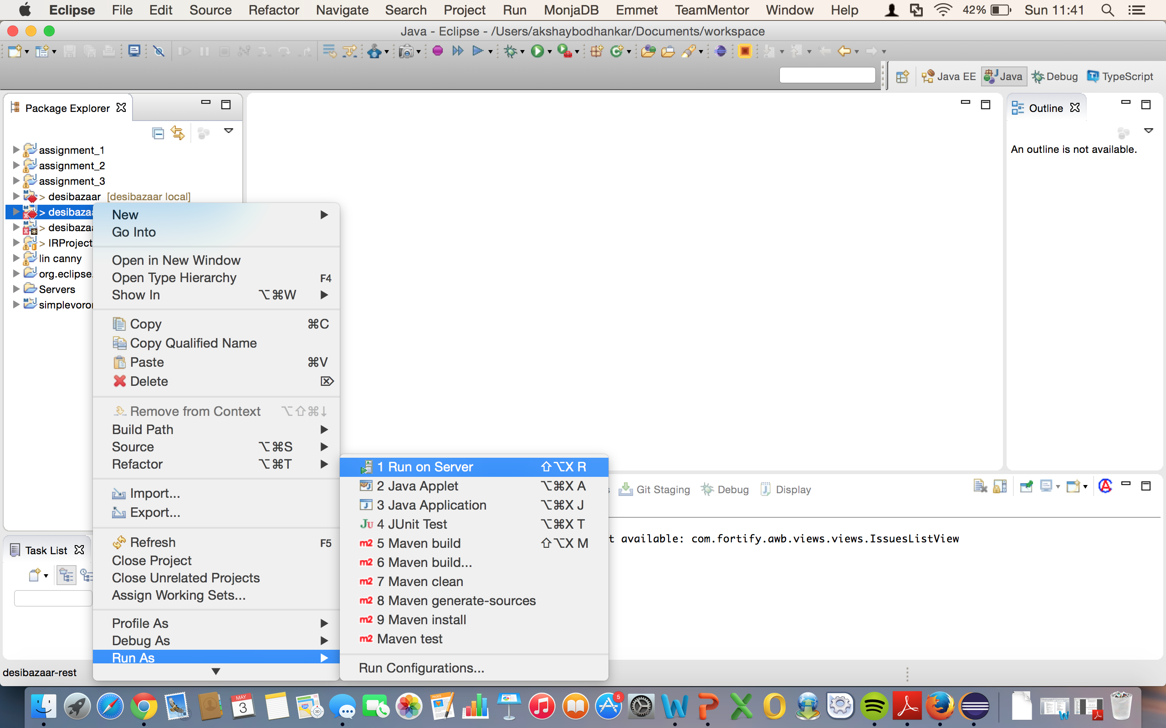

* Then deploy the desibazaar-web project by following the same steps. Right click and then run on server.

After the server has been deployed. Hit the following link, this will take you to the login page of the website.

<http://localhost:8080/desibazaar-web/#/login>

**Instructions for getting started**

* First thing a user needs to do is register himself on the website.
* Then he can login using the registered credentials.
* The first page after logging in will show the items available for auction.
* The user can browse through the website and subscribe to the items of his choice.
* Also he can add an item that he wants to sell under the “My Items” tab.